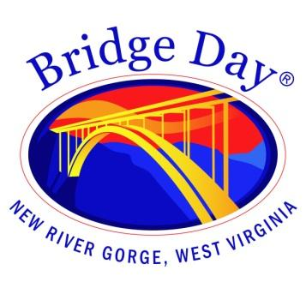

Bridge Day Commission

Fayetteville Town Hall | September 20, 2023 at 1:30 pm

Meeting Agenda
31 Days

Call to order

- Minutes from August 16, 2023 - review and approval

- Old Business
  - Nomination and approval of Emergency Services advisory position
  - Day of event contact phone numbers

- New Business
  - Point of contact spokesperson
  - Press release

- Report from BDC representatives

- Round the room

- Next meeting date - September 27, 2023

- Adjourn

